Integrating the Healthcare Enterprise



IHE Patient Care Coordination (PCC)

Technical Framework Supplement

eNursing Summary
(ENS)

Public Comment

Date: June 01, 2010
Author: Marcia Veenstra
Email: <ihe@himss.org>
Foreword
This page is standard language for all IHE supplements. The Introduction section following will list all other IHE documents that are modified by this supplement. This document is a supplement to the IHE Patient Care Coordination Technical Framework 4.0. The technical framework can be found at http://www.ihe.net/Technical_Framework/index.cfm#pcc.
This and all IHE supplements are written as changes to a base document. The base document is normally one or more IHE Final Text documents. Supplements tell a technical editor and the reader how to modify the final text (additions, deletions, changes in wording). In order to understand this supplement, the reader needs to read and understand all of the base documents that are modified by this supplement.
In this supplement you will see “boxed” instructions similar to the following:
Replace Section X.X by the following:
These “boxed” instructions are for the author to indicate to the Volume Editor how to integrate the relevant section(s) into the overall Technical Framework.
This format means the reader has to integrate the base documents and the supplement. When the material in the supplement is considered ready for incorporation into the final text of the Technical Framework, the IHE committees will update the technical framework documents with the final text. Supplements are written in this format to avoid duplication material. This means that two IHE documents (one possibly final text, and the other a supplement) should not contain contradictory material.
Text in this document is not considered final for the Technical Framework. It becomes Final Text only after the IHE Patient Care Coordination Technical Committee ballots the supplement (after testing) and agrees that the material is ready for integration with the existing Technical Framework documents.
It is submitted for Trial Implementation starting August XX, 20XX.
Comments on this supplement may be submitted http://forums.rsna.org:
- Select the “IHE” forum
- Select Patient Care Coordination Technical Framework
- Select 2009-2010 Supplements for Public Comment
- Select eNursing Summary

Please use the Public Comment Template provided there when starting your New Thread.

Details about IHE may be found at: www.ihe.net

Details about the IHE Patient Care Coordination may be found at: http://www.ihe.net/Domains/index.cfm
Details about the structure of IHE Technical Frameworks and Supplements may be found at: http://www.ihe.net/About/process.cfm and http://www.ihe.net/profiles/index.cfm

TABLE OF CONTENTS

Public Comment 0
Introduction 4
Open Issues and Questions 4
Closed Issues 4
Volume 1 – Profiles 6
1.1.5 Copyright Permissions 6
2.5 Dependencies of the PCC Integration Profiles 6
2.7 History of Annual Changes 6
X.1 Purpose and Scope 7
X.2 Process Flow 7
X.2.1 Use Cases 7
X.2.2 Diagrams 8
X.3 Actors/Transactions 10
X.3.1 Requirements of Actors 11
X.4 Options 11
X.5 Groupings 11
X.6 Security Considerations 11
X.7 Content Modules 12
X.8 References 13
Glossary 14
Volume 2 – Transactions and Content Modules 15
5.0 Namespaces and Vocabularies 16
5.1 IHE Format Codes 16
6.0 PCC Content Modules 17
6.3 HL7 Version 3.0 Content Modules 17
6.3.3 CDA Section Content Modules 21

Introduction
This supplement is written for Trial Implementation. It is written as changes to the documents listed below. The reader should have already read and understood these documents:
- PCC Technical Framework Volume 1, Revision 5.0
- PCC Technical Framework Volume 2, Revision 5.0
This supplement also references other documents. The reader should have already read and understood these documents:
- IT Infrastructure Technical Framework Volume 1, Revision 6.0
- IT Infrastructure Technical Framework Volume 2, Revision 6.0
- IT Infrastructure Technical Framework Volume 3, Revision 6.0
- The Patient Identifier Cross-Reference (PIX) and Patient Demographic Query (PDQ) HL7 v3 Supplement to the IT Infrastructure Technical Framework.
- HL7 and other standards documents referenced in Volume 1 and Volume 2
- Dilbert 2.0: 20 Years of Dilbert by Scott Adams, ISBN-10: 0740777351, ISBN-13: 978-0740777356
This supplement adds the eNursing Summary profile to Volume I of the IHE PCC Technical Framework, the Nursing Summary Document Content Module and related modules to Volume II. This profile continues the work of Patient Plan of Care profile (PPOC) as it adds evaluation, handoff communication and discharge data communication to the PPOC.

Open Issues and Questions
- Nurse give/receive report (signature) – does this need to be called out specifically in the CDA Header modules?
- Demographics?

Closed Issues

- Nursing Subcommittee survey ( HIMSS) of more than 575 practicing nurses provided much information regarding data elements needed
- General
Shift to shift- change in provider or service
- Need Assistance with Volume 2
- Find LOINC and SNOMED codes

Volume 1 – Profiles
Add the following to section 1.1.5

1.1.5 Copyright Permissions
No new permissions were needed. Refer to PPOC for American Nurses Association reference.
Add the following to section 2.5

2.5 Dependencies of the PCC Integration Profiles
<Profile Name> | <?> | <?> | <->
Medical Summary | <?> | <?> | <->
Functional Status Assessment | FSA
Patient Plan of Care | PPOC

Add the following to section 2.7

2.7 History of Annual Changes

Add Section X
X eNursing Summary Content Profile
This profile develops data sets related to specific clinical enviroment as a process to create safe, effective communication, ensuring continuity as the patient moves through care transitions. Transitions, or “hand-offs”, occur multiple times each day in a hospital and at every change of care location.
For example: On a nursing unit of 44 patients with 10 nurses per 12 hour shift a minimum of 88 reports are given daily. This does not include off unit reports for lunch breaks, special procedures lab, physical or occupational therapy or general radiology reports on the patient given by the unit nurse.
Though it is recognized that communication must be interdisciplinary in nature, the scope of this profile is based on the nursing process as adapted from the scientific method. Future work is to include multidisciplinary care provider summary information to become part of the Patient Plan of Care.

X.1 Purpose and Scope
The Joint Commission, in 2005, analyzed 3000 adverse events. Communication was the contributing factor in 70% of these events. Communication breakdowns during transitions of patient care accounted for a 50% error rate. This study in conjunction with the work of Institutes for Healthcare Improvement and other research, acknowledged the serious need for improvement. .
To ensure consistent information, accurate and concise communication must be present during patient care transitions and hand off. Transitions, or “hand-offs”, occur multiple times each day in a hospital and at every change of care location. For example: On a nursing unit of 44 patients with 10 nurses per 12 hour shift a minimum of 88 reports are given daily. This does not include off unit reports for lunch breaks, special procedures lab, physical or occupational therapy or general radiology reports on the patient given by the unit nurse.
Standardization work has been initiated by the HL7 Clinical Document Architecture group, nursing process and ISO Reference Terminology Model. European eHealth has called for a summary which crosses borders and provides a timely transfer. IHE could solve the issue by creating an interoperable nursing eHealth summary which is possible to use nationally and internationally
The purpose of eNursing Summary Profile is to create an interoperable summary of nursing related data that communicates the ongoing patient care needs to another care provider.The data elements were determined by an international survey of 589 nurses. Data element information for the selected Use Cases are documented in a summary table for ease of comparison.

X.2 Process Flow

X.2.1 Use Cases

X.2.1.1 Use Case #1 Nursing Home patient admitted to Acute Care
A 76-year-old diabetic female patient in a long-term care facility, who typically only requires the support of prepared meals and assistance with medications, has experienced an abrupt change in behavior as indicated by serial, standardized functional status assessments. Over the past 48 hours, the patient has been complaining of feeling weak and has become increasingly lethargic. Finally, she refuses to get out of bed, complaining of chills. The nurse takes her temperature and determines that she has a low-grade fever. In addition, the maximum sliding-scale insulin dose indicated in the medication orders is not controlling the patient’s blood sugar as determined by finger-stick glucose measurement. The primary care physician was called and a decision was made to transfer the patient to an acute care hospital for follow-up. To prepare for the transfer, the charge nurse prepares the long-term care nursing documentation with an additional functional assessment, indicating both what has been typical for this patient, and what the patient is currently exhibiting. The patient is transferred to the acute care setting, where her fever and glucose level are stabilized over a period of 3 days. She is then transferred back to the long-term care facility.

X.2.1.2 Use Case #2 Perioperative Care

A 70 year old male is scheduled for a Right Total Hip Arthroplasty with a diagnosis of osteoarthritis. The patient was instructed to report to Pre-Op to begin the perioperative process with the intent of being admitted to the hospital post the perioperative procedure. The patient has no other significant health history. This patient will be seen in Pre-Op, Operating Room, PACU and then transferred to the nursing unit. In each phase of care, additional services from ancillary areas are needed.

X.3.1.3 Use Case #3 Home Health to Hospice
Rita Wong is an 82year old Asian female with end stage emphysema who is being discharged from Home Health and admitted to Hospice Home Care. The Home Care Nurse reports Rita’s original diagnosis was made 8 years ago. She lives alone with her cats. Her daughter Margaret Snyder is present at the visit, but she lives out of state and is her health care proxy. Margaret is planning to move in with her mother within the next two weeks. Mrs. Wong speaks broken English and does not always appear to understand the admission presentation of her Medicare Hospice benefit. Her pain is currently managed with Decadron 2mg PO every other day and Decadron 1mg on the off days. She uses oxygen 2liters/min via nasal cannula continuously except when she smokes. She sometimes forgets to turn off the flow of oxygen and leave the canulea hanging over the lamp shade when she smokes. There are numerous burn marks on the easy chair and on the carpet. She has a neighbor who looks in and helps her with her cat’s litter box. She is currently receiving Meals-on-Wheels. She reports a 13 pounds weight loss over the last 2 months. She takes Atrovent inhailor 2 puffs q4-6 hrs for shortness of breath. She is taking Black Magic to counteract the constipation secondary to her use of Tylenol with Codiene 2 tablets q 4 hours PO for chronic back pain that has been exacerbated due to diminished mobility. She has expressed interest in receiving spiritual support and requests a Buddhist priest to make a home visit. She is also requesting a volunteer to come play Marjong with her. At the admission visit it was determined that Rita will need inpatient Hospice respite care for 5 days prior to starting Hospice Home care enabling daughter to have time to move.

X.2.2 Diagrams

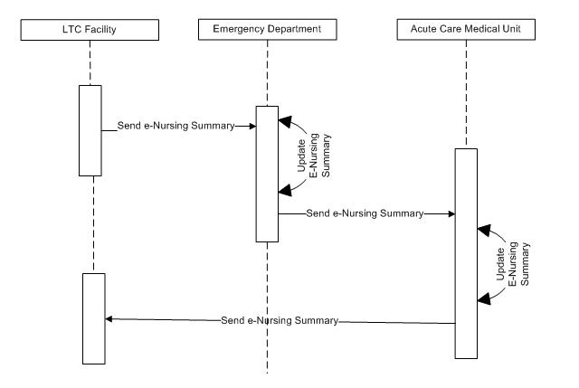
Figure X.2.2-1. Use Case #1 Basic Process Flow in eNursing Summary Profile

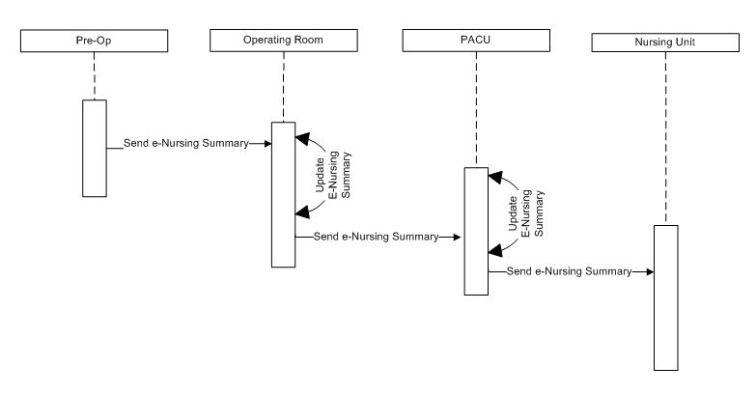
Figure X.2.2-2. Use Case #2 Basic Process Flow in eNursing Summary Profile

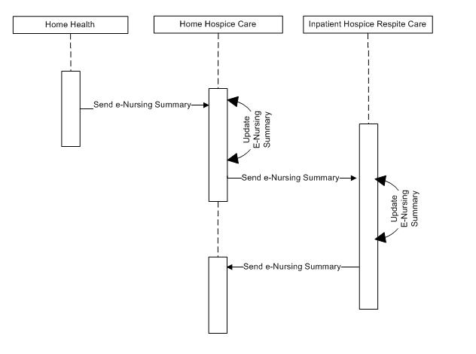
Figure X.2.2-3. Use Case #3 Basic Process Flow in eNursing Summary Profile

X.3 Actors/Transactions
There are two actors in this profile, the Content Creator and the Content Consumer. Content is created by a Content Creator and is to be consumed by a Content Consumer. The sharing or transmission of content from one actor to the other is addressed by the appropriate use of IHE profiles described below, and is out of scope of this profile. A Document Source or a Portable Media Creator may embody the Content Creator Actor. A Document Consumer, a Document Recipient or a Portable Media Importer may embody the Content Consumer Actor. The sharing or transmission of content or updates from one actor to the other is addressed by the use of appropriate IHE profiles described in the section on Content Bindings with XDS, XDM and XDR. in PCC TF_2:4.1


Figure X.3-1 Actor Diagram

X.3.1 Requirements of Actors

X.4 Options
Options that may be selected for this Profile are listed in the table X.4-1 along with the Actors to which they apply. Dependencies between options when applicable are specified in notes.

Table X.4-1 eNursing Summary Actors and Options
Actor | Option | Section
Content Consumer | View Option (See Note 1)  Document Import Option (See Note 1)  Section Import Option (See Note 1)  Discrete Data Import Option (See Note 1) | PCC TF-2: 3.0.1  PCC TF-2: 3.0.2  PCC TF-2: 3.0.3  PCC TF-2: 3.0.4
Content Creator | No options defined
Note 1: The Actor shall support at least one of these options.

X.5 Groupings

X.6 Security Considerations

X.7 Content Modules

Table X.7-1 eNursing Summary Content
eNursing Summary | PCC Template
Allergies | Allergies and Other Adverse Reactions
Activity Restriction | Care Plan
Code Status | Coded Advance Directives
Level of Consciousness | Assessments
Cognitive abilities | History of Cognitive Function
Complications | Active Problems
Chief Complaint | Chief complaint
Admission Diagnosis | Hospital Adm Diagnosis
Discharge Diagnosis | Discharge Diagnosis
Date/time of report | Header Modules
Demographics | Header Modules
Devices | Medical Devices
Diet Restrictions | Diet Restrictions
Fluid Management | Fluid Management
Health Assessment | Assessment
Isolation | Procedures and Interventions
Lab Values | Coded Results
Medications | Medications
Mobility/fall risk | Procedures and Interventions
Nurse rpt give/receive (signature) | Header Modules
Pain | Pain Scale Assessment
Physician(s) Name | Header Modules
Precautions | Treatment Plan
Primary language spoken | Header Modules
Procedure | Procedures and Interventions
Order list | Provider Orders
Oxygen | Treatment Plan
Special needs | Assessment
Vital Signs | Vital Signs
Wound | Assessment

X.8 References
American Nurses Association.(2004). Nursing: Scope & Standards of Practice. Silver Spring, MD: ANA.

Glossary
Add the following terms to the Glossary:

Volume 2 – Transactions and Content Modules

5.0 Namespaces and Vocabularies
codeSystem | codeSystemName | Description

5.1 IHE Format Codes

Profile | Format Code | Media Type | Template ID
e-Nursing Summary (ENS) | urn:ihe:pcc:ens:2010 | text/xml | 1.3.6.1.4.1.19376.1.5.3.1.1.20.1.3

6.0 PCC Content Modules

6.3 HL7 Version 3.0 Content Modules
Add section 6.3.1.A

6.3.1.A eNursing Summary 1.3.6.1.4.1.19376.1.5.3.1.1.20.1.3

6.3.1.A.1 Format Code
The XDSDocumentEntry format code for this content is urn:ihe:pcc:ens:2010

6.3.1.A.2 LOINC Code
The LOINC code for this document is 28651-8 Nurse Transfer note

6.3.1.A.3 Standards
CCD | ASTM/HL7 Continuity of Care Document
CDAR2 | HL7 CDA Release 2.0
CDTHP | CDA for Common Document Types History and Physical Notes (DSTU)

6.3.1.A.4 Specification
This section references content modules using Template Id as the key identifier. Definitions of the modules are found in either:
- IHE Patient Care Coordination Volume 2: Final Text
- IHE PCC Content Modules 2010-2011 Supplement

Data Element Name | Opt | Template ID | Value Set Template Id
Header Modules | R | 1.3.6.1.4.1.19376.1.5.3.1.2
Allergies and Other Adverse Reactions | R | 1.3.6.1.4.1.19376.1.5.3.1.3.13
Care Plan | R | 1.3.6.1.4.1.19376.1.5.3.1.3.31
Coded Advance Directives | R | 1.3.6.1.4.1.19376.1.5.3.1.3.35
Active Problems | R | 1.3.6.1.4.1.19376.1.5.3.1.3.6
Chief complaint | R | 1.3.6.1.4.1.19376.1.5.3.1.1.13.2.1
Hospital Admission Diagnosis | R | 1.3.6.1.4.1.19376.1.5.3.1.3.3
Discharge Diagnosis | R | 1.3.6.1.4.1.19376.1.5.3.1.3.7
Medical Devices | R | 1.3.6.1.4.1.19376.1.5.3.1.1.5.3.5
Diet Restrictions | R | 1.3.6.1.4.1.19376.1.5.3. 1.1.20.2.2
Fluid Management | R | 1.3.6.1.4.1.19376.1.5.3.1.1.20.2.3
Coded Results | R | 1.3.6.1.4.1.19376.1.5.3.1.3.28
Medications | R | 1.3.6.1.4.1.19376.1.5.3.1.3.21
Pain scale assessment section | R | 1.3.6.1.4.1.19376.1.5.3.1.1.12.2.2
Treatment Plan | R | 1.3.6.1.4.1.19376.1.5.3.1.3.31
Procedures and Interventions  This section shall include isolation, mobility/fall risk and procedures. | R | 1.3.6.1.4.1.19376.1.5.3.1.1.13.2.11
Provider Orders | R | 1.3.6.1.4.1.19376.1.5.3.1.1.20.2.1
Assessment  This section shall include level of consciousness, health assessment, special needs and wound. | R | 1.3.6.1.4.1.19376.1.5.3.1.1.13.2.4
Vital Signs | R | 1.3.6.1.4.1.19376.1.5.3.1.3.25
R = Required; R2 = Required if data present; O = Optional; C = Conditional

6.3.1.B.5 Conformance
CDA Release 2.0 documents that conform to the requirements of this content module shall indicate their conformance by the inclusion of the appropriate <templateId> elements in the header of the document. This is shown in the sample document below. A CDA Document may conform to more than one template. This content module inherits from the Medical Summary content module, and so must conform to the requirements of that template as well, thus all <templateId> elements shown in the example below shall be included.

<ClinicalDocument xmlns='urn:hl7-org:v3'>
<typeId extension="POCD_HD000040" root="2.16.840.1.113883.1.3"/>
<templateId root='1.3.6.1.4.1.19376.1.5.3.1.1.2'/><!--Medical Summary-->
<templateId root='1.3.6.1.4.1.19376.1.5.3.1.1.20.1.3'/><!--eNursing Summary-->
<id root=' ' extension=' '/>
<code code='28651-8' displayName='Nursing Transfer note'
codeSystem='2.16.840.1.113883.6.1' codeSystemName='LOINC'/>
<title>eNursing Summary</title>
<effectiveTime value='20090506012005'/>
<confidentialityCode code='N' displayName='Normal'
codeSystem='2.16.840.1.113883.5.25' codeSystemName='Confidentiality' />
<languageCode code='en-US'/>
:
<component><structuredBody>
<component>
<section>
<templateId root='1.3.6.1.4.1.19376.1.5.3.1.3.13'/>
<!-- Required Allergies and Other Adverse Reactions Section Section content -->
</section>
</component>
<component>
<section>
<templateId root='1.3.6.1.4.1.19376.1.5.3.1.3.31'/>
<!-- Required Care Plan Section content -->
</section>
</component>
<component>
<section>
<templateId root='1.3.6.1.4.1.19376.1.5.3.1.3.35'/>
<!-- Required Coded Advance Directives Section content -->
</section>
</component>
<component>
<section>
<templateId root='1.3.6.1.4.1.19376.1.5.3.1.3.6'/>
<!-- Required Active Problems Section content -->
</section>
</component>
<component>
<section>
<templateId root='1.3.6.1.4.1.19376.1.5.3 1.1.13.2.1'/>
<!-- Required Chief complaint Section content -->
</section>
</component>
<component>
<section>
<templateId root='1.3.6.1.4.1.19376.1.5.3.1.3.3'/>
<!-- Required Hospital Admission DiagnosisSection content -->
</section>
</component>
<component>
<section>
<templateId root='1.3.6.1.4.1.19376.1.5.3.1.3.7'/>
<!-- Required Discharge Diagnosis Section content -->
</section>
</component>
<component>
<section>
<templateId root='1.3.6.1.4.1.19376.1.5.31.1.5.3.5'/>
<!-- Required Medical Devices Section content -->
</section>
</component>
<component>
<section>
<templateId root='1.3.6.1.4.1.19376.1.5.3. 1.1.20.2.2'/>
<!-- Required Diet Restrictions Section content -->
</section>
</component>
<component>
<section>
<templateId root='1.3.6.1.4.1.19376.1.5.31.1.20.2.3'/>
<!-- Required Fluid Management Section content -->
</section>
</component>
<component>
<section>
<templateId root='1.3.6.1.4.1.19376.1.5.3. 1.3.28'/>
<!-- Required Coded Results Section content -->
</section>
</component>
<component>
<section>
<templateId root='1.3.6.1.4.1.19376.1.5.3.1.3.19'/>
<!-- Required Medications Section content -->
</section>
</component>
<component>
<section>
<templateId root='1.3.6.1.4.1.19376.1.5.3.1.1.12.2.2'/>
<!-- Required Pain Scale Assessment Section content -->
</section>
</component>
<component>
<section>
<templateId root='1.3.6.1.4.1.19376.1.5.3. 1.3.31'/>
<!-- Required Treatment Plan Section content -->
</section>
</component>
<component>
<section>
<templateId root='1.3.6.1.4.1.19376.1.5.3. 1.1.13.2.11'/>
<!-- Required Procedures and Interventions Section content -->
</section>
</component>
<component>
<section>
<templateId root='1.3.6.1.4.1.19376.1.5.3.1.1.20.2.1'/>
<!-- Required Provider Orders Section content -->
</section>
</component>
<component>
<section>
<templateId root='1.3.6.1.4.1.19376.1.5.3.1.1.13.2.4'/>
<!-- Required Assessment Section content -->
</section>
</component>
<component>
<section>
<templateId root='1.3.6.1.4.1.19376.1.5.3.1.3.25'/>
<!-- Required Vital Signs Section content -->
</section>
</component>
<component>
<section>
<templateId root='1.3.6.1.4.1.19376.1.5.3. 1.1.20.2.1'/>
<!-- Required History of Cognitive Function Section content -->
</section>
</component>
</structuredBody></component>
</ClinicalDocument>
Figure 6.3.1.B.5-1 Sample eNursing Summary Document

The first three documents can be located on the IHE Website at http://www.ihe.net/Technical_Framework/index.cfm#IT. The remaining documents can be obtained from their respective publishers.

